DAY 4 LAB EXPERIMENTS

Q1. Mall Customer Clustering
Prepare a dataset for a supermarket/mall containing Customer ID, Age, Gender, Annual Income and Spending Score. Perform Clustering Analysis to segment customers based on Annual Income and Spending Score.

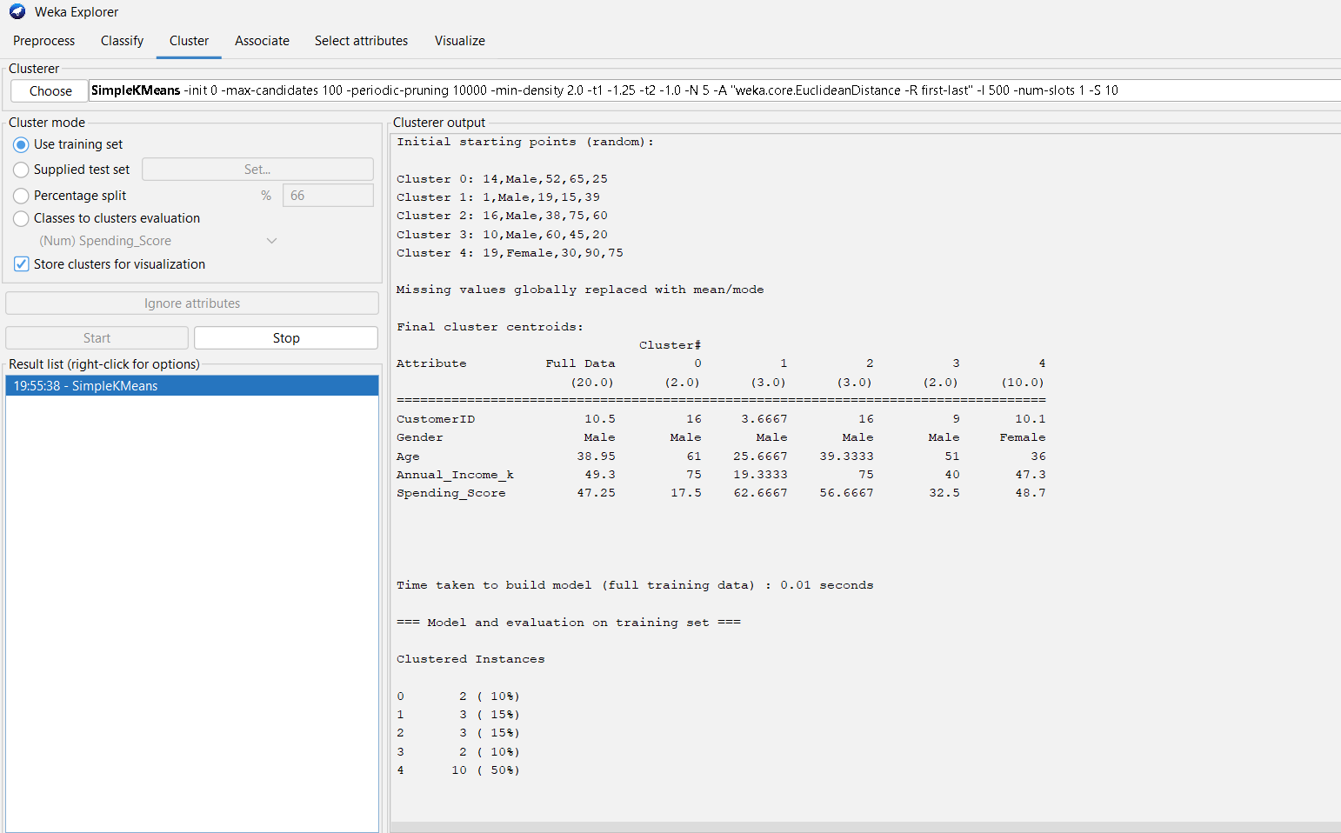
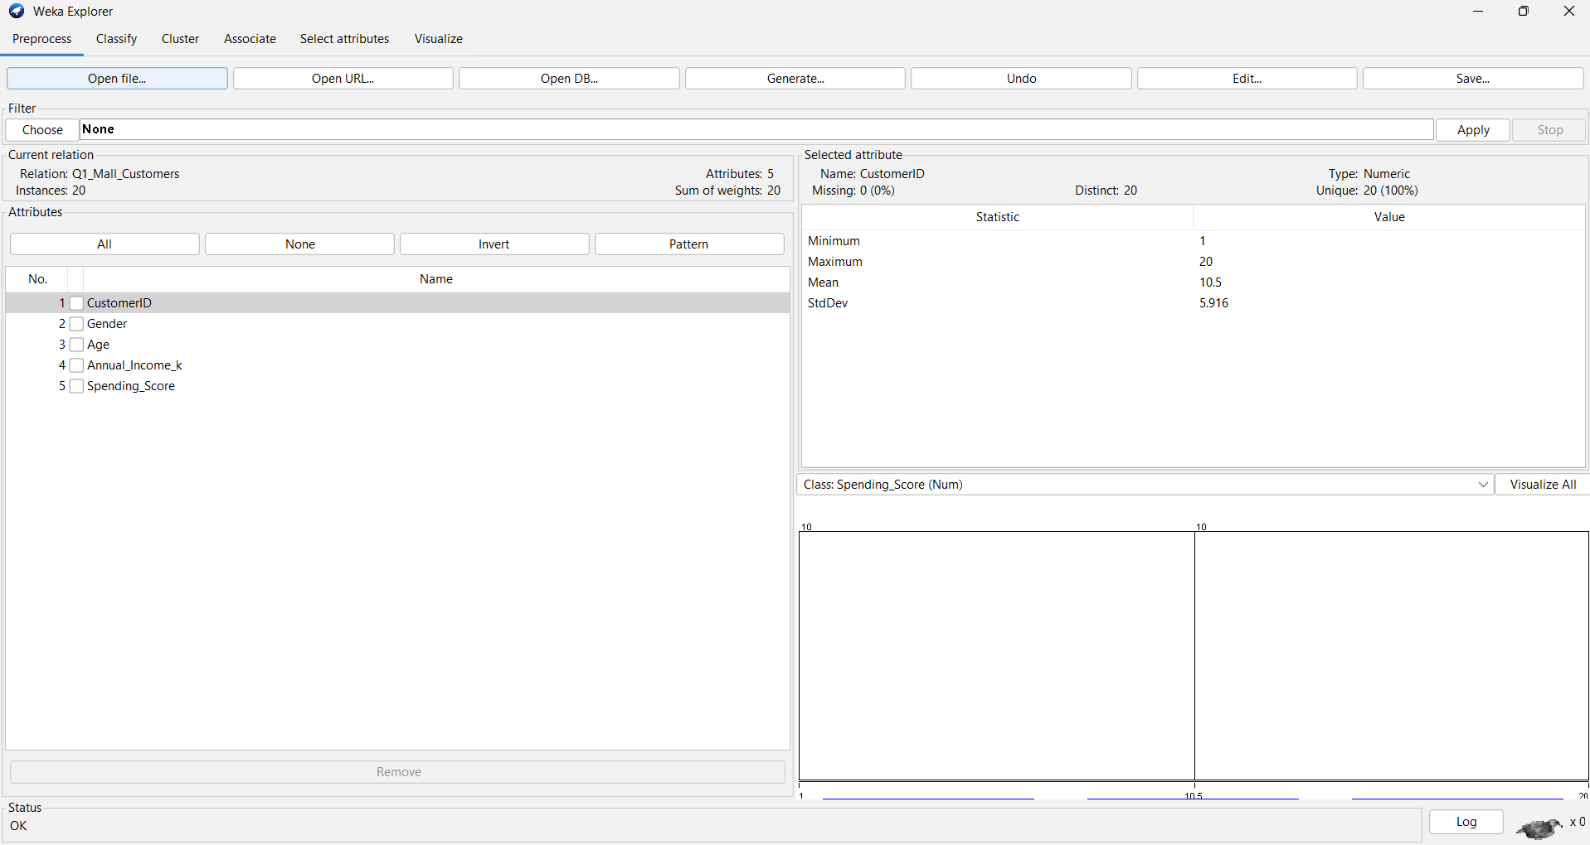

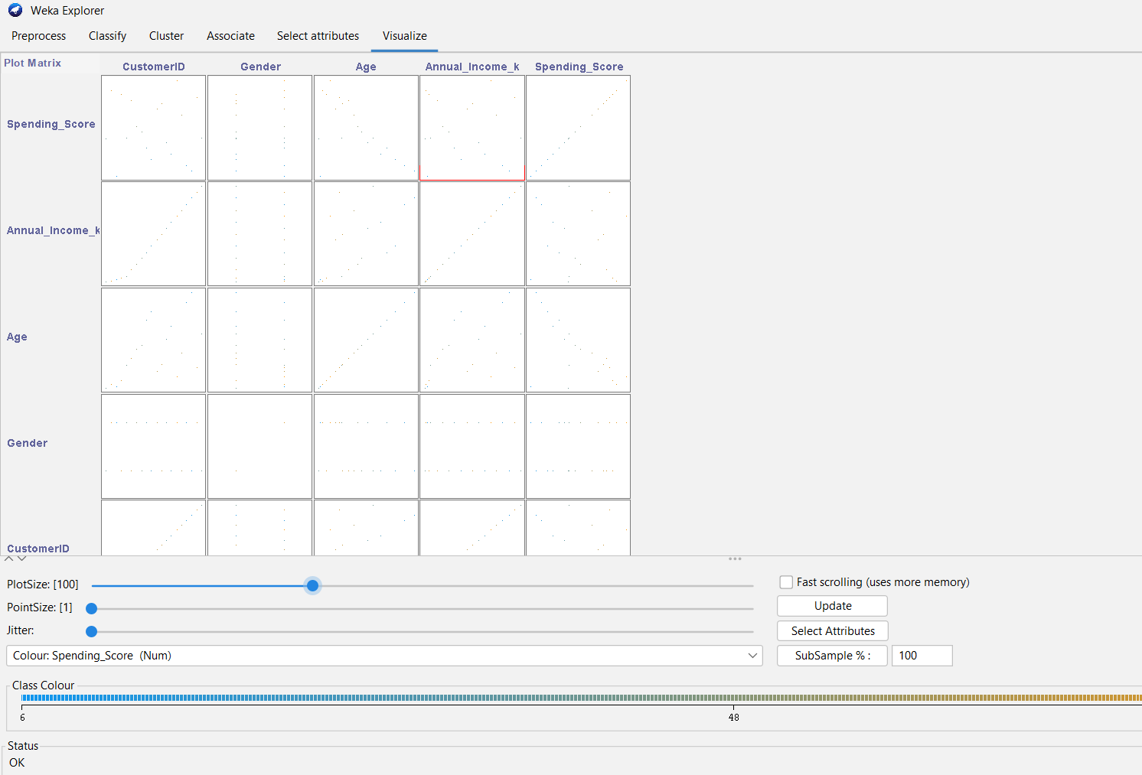

Q2. K-Means Clustering using WEKA
Create the given employee dataset in CSV format and perform K-Means clustering in WEKA. Change the cluster size, plot the graph and illustrate the cluster visualization.

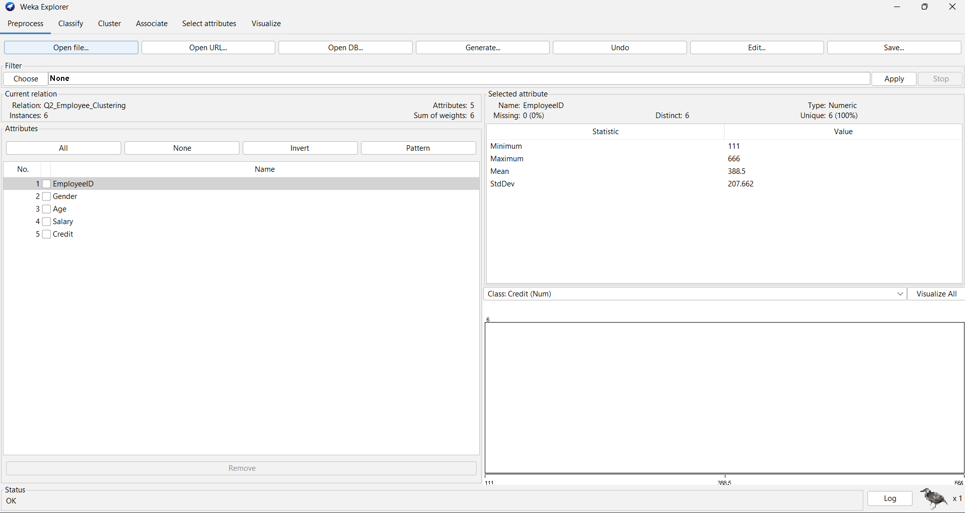

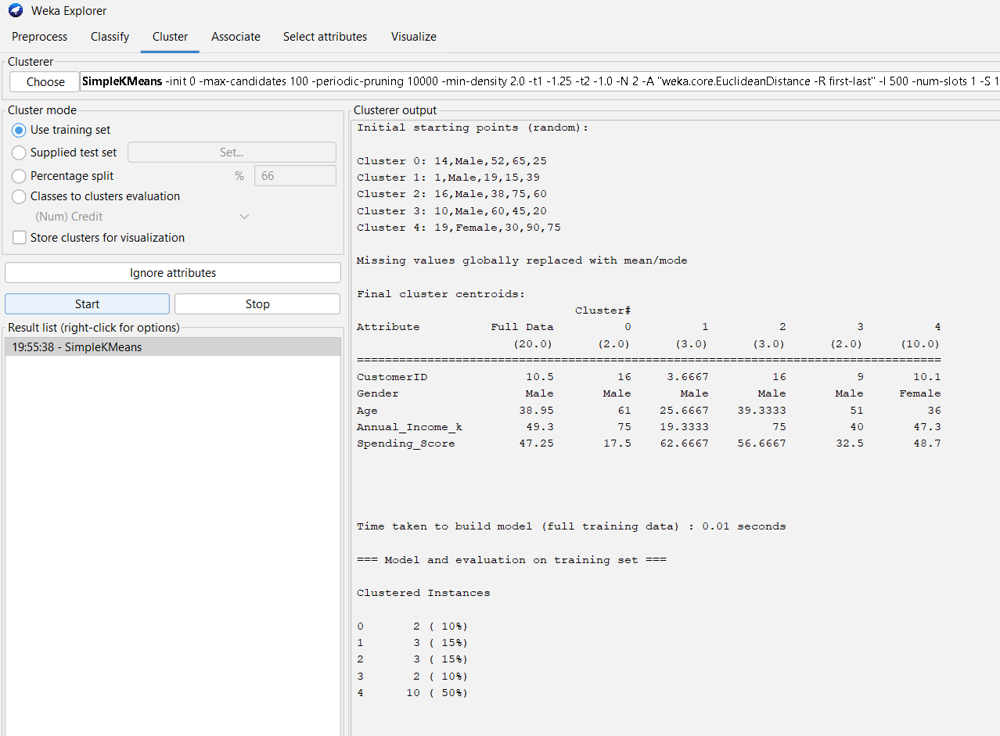

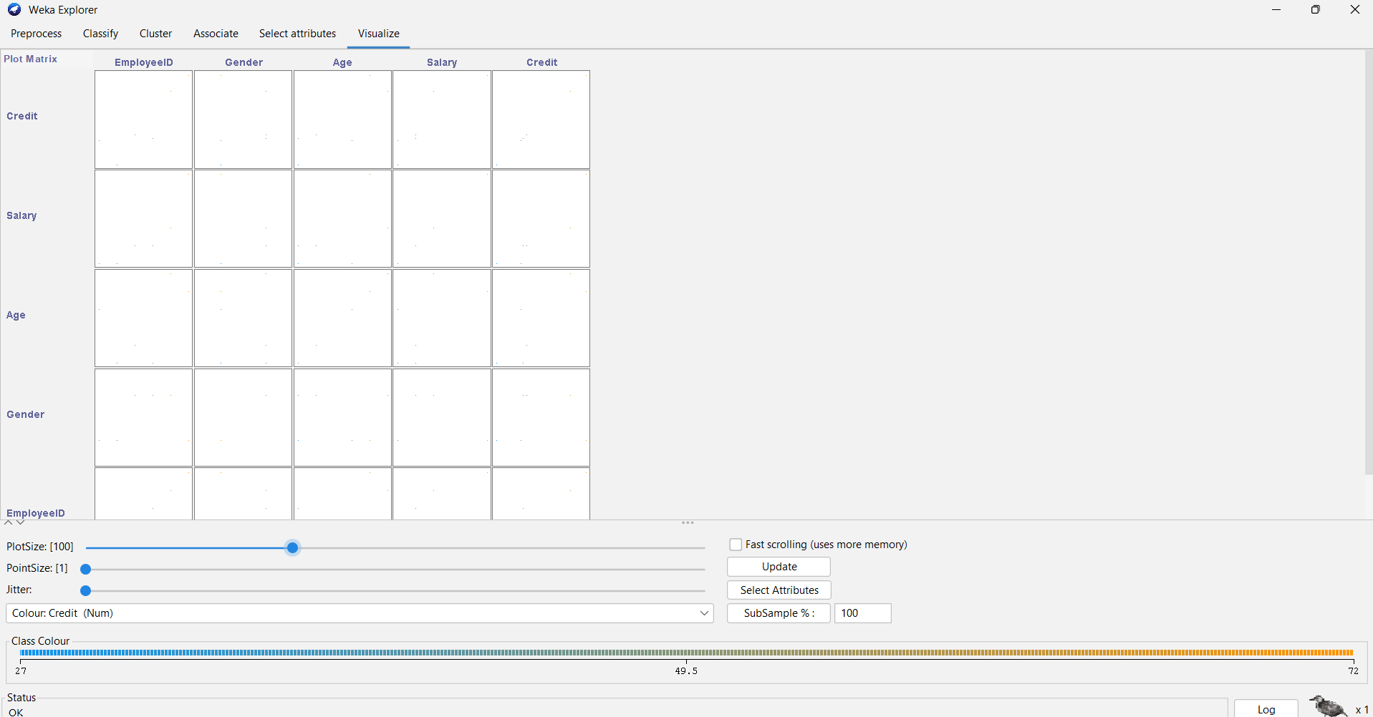

Q3. Naïve Bayes vs SVM
Perform categorical data prediction using Naïve Bayes classification through WEKA using any dataset. Compare Naïve Bayes with SVM using the classifier summaries and plot the graph.

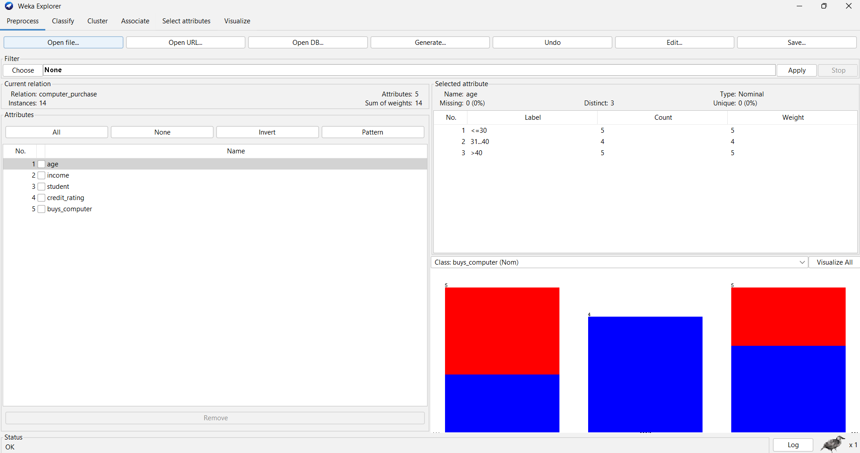

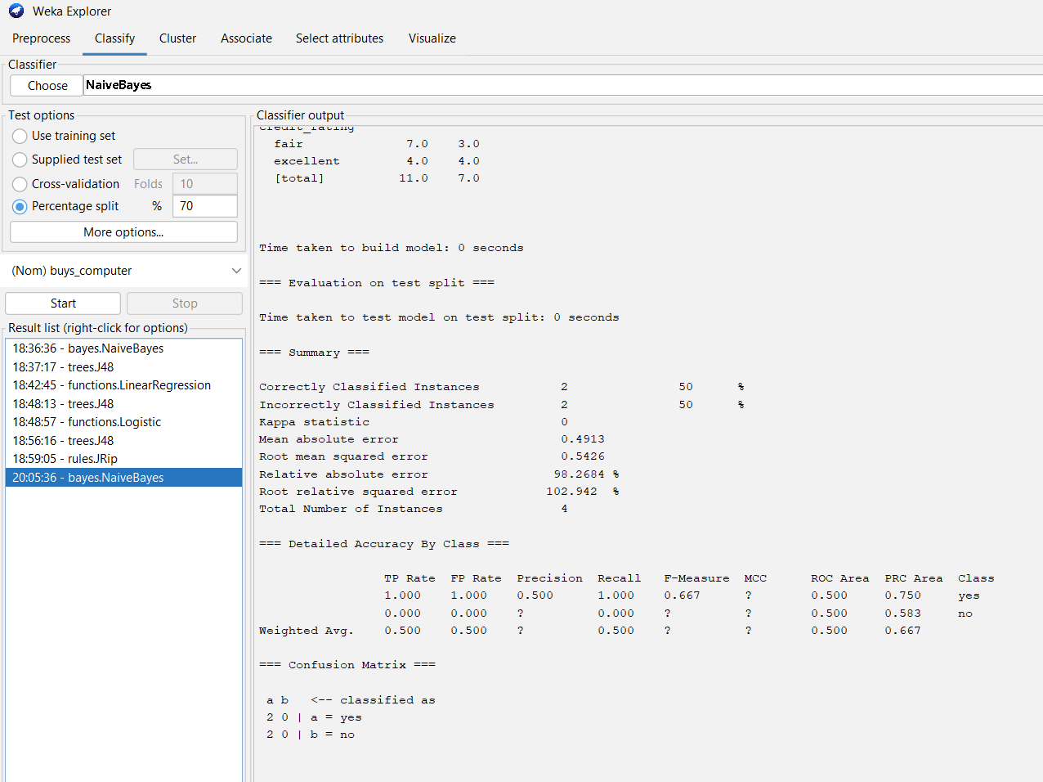

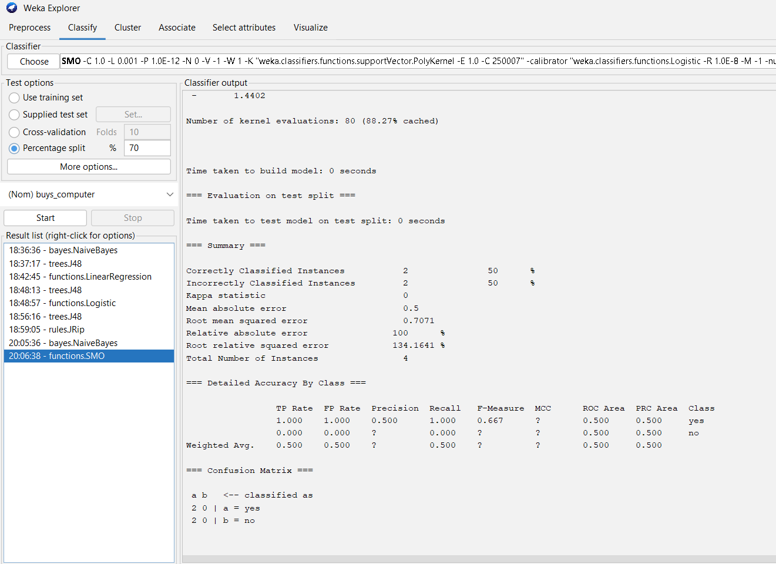

Q4. Vegetarian / Non-Vegetarian Count
Given the table of persons and their vegetarian status:
Find how many are vegetarian
Find how many are non-vegetarian
Determine which type has the greater total count.

Answer
From the given table:
- Vegetarian = 7
- Non-Vegetarian = 3
Therefore,
Result
The number of vegetarian persons is greater than the number of non-vegetarian persons.
Final Answer: Vegetarian = 7, Non-Vegetarian = 3.

Q5. Scatter Plot
Given the number of mobile phones sold (x) and money (y), create a scatter plot to show the relationship between mobile phones sold and money.
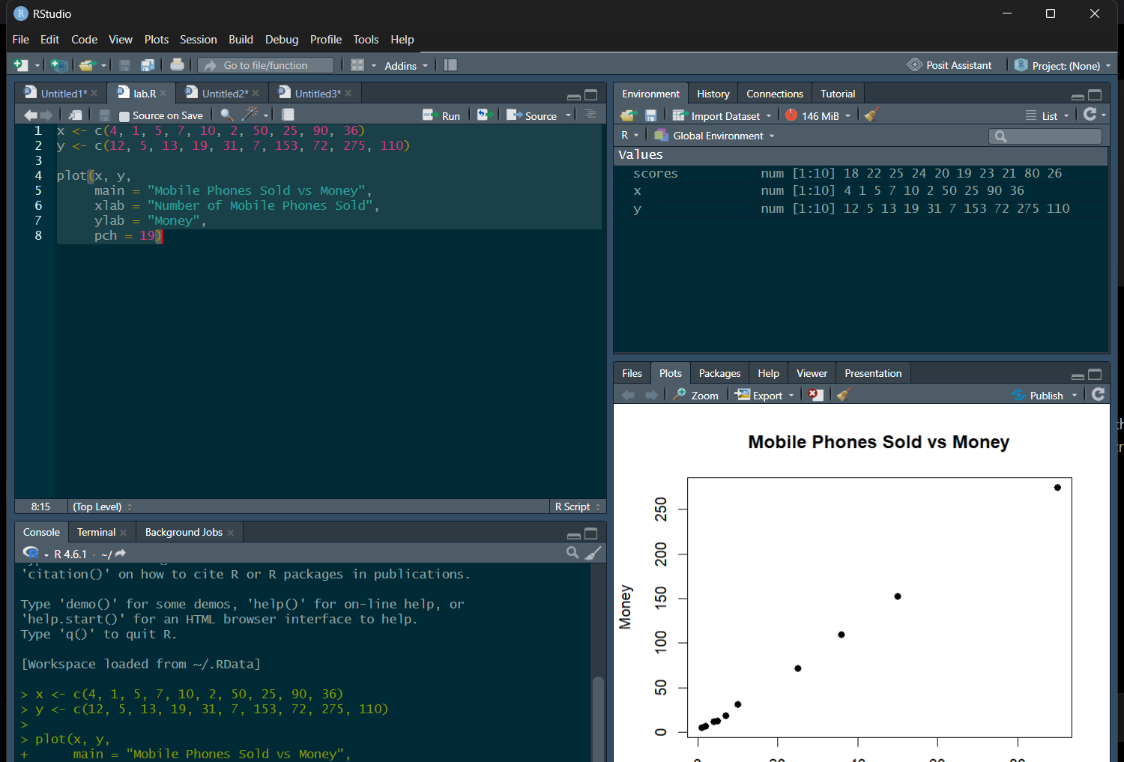

Q7. Diabetes Decision Tree vs SVM
Perform Diabetes Data prediction using Decision Tree classifier in WEKA.
Compare it with SVM and:
Show accuracy
Calculate F1 measure
Plot the graph
Explain the summary of results. 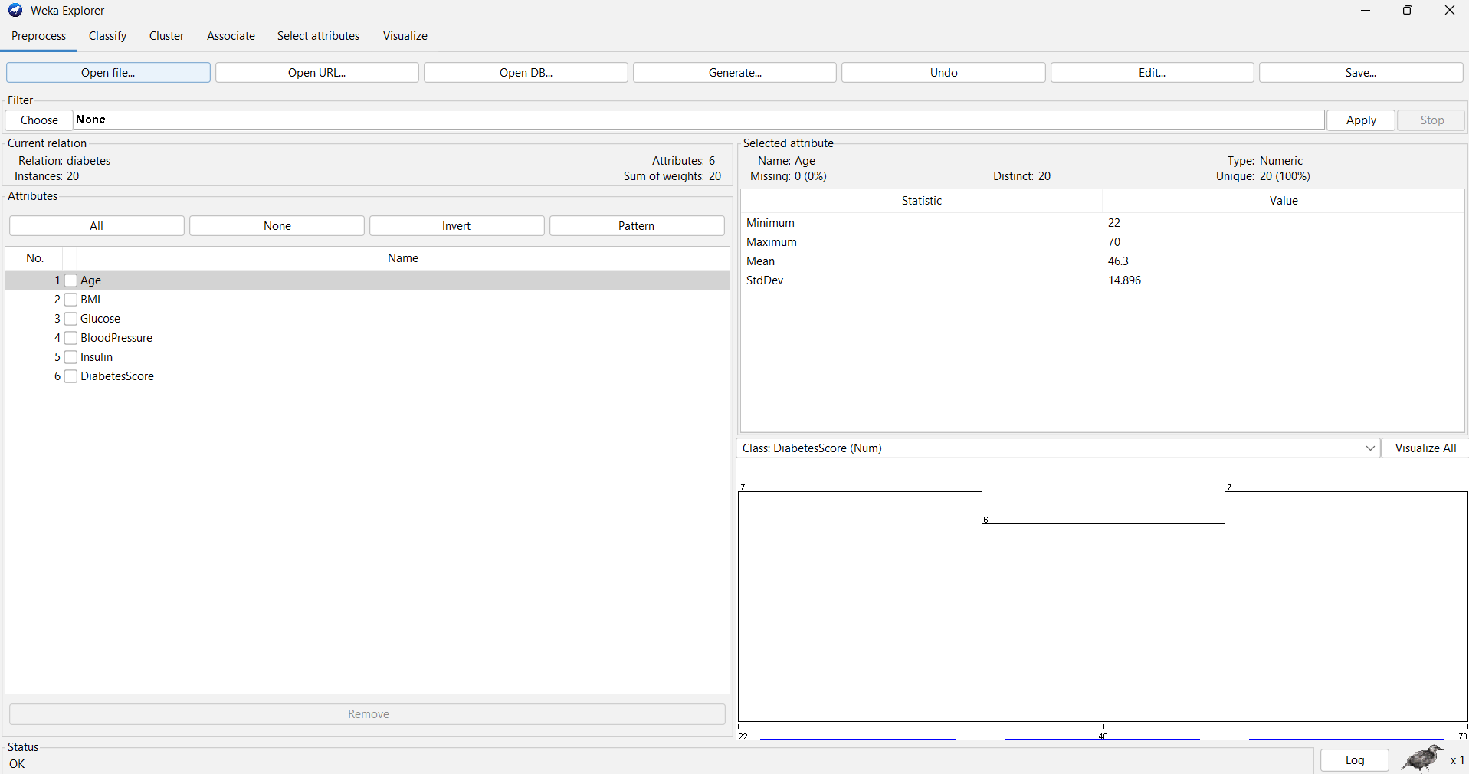

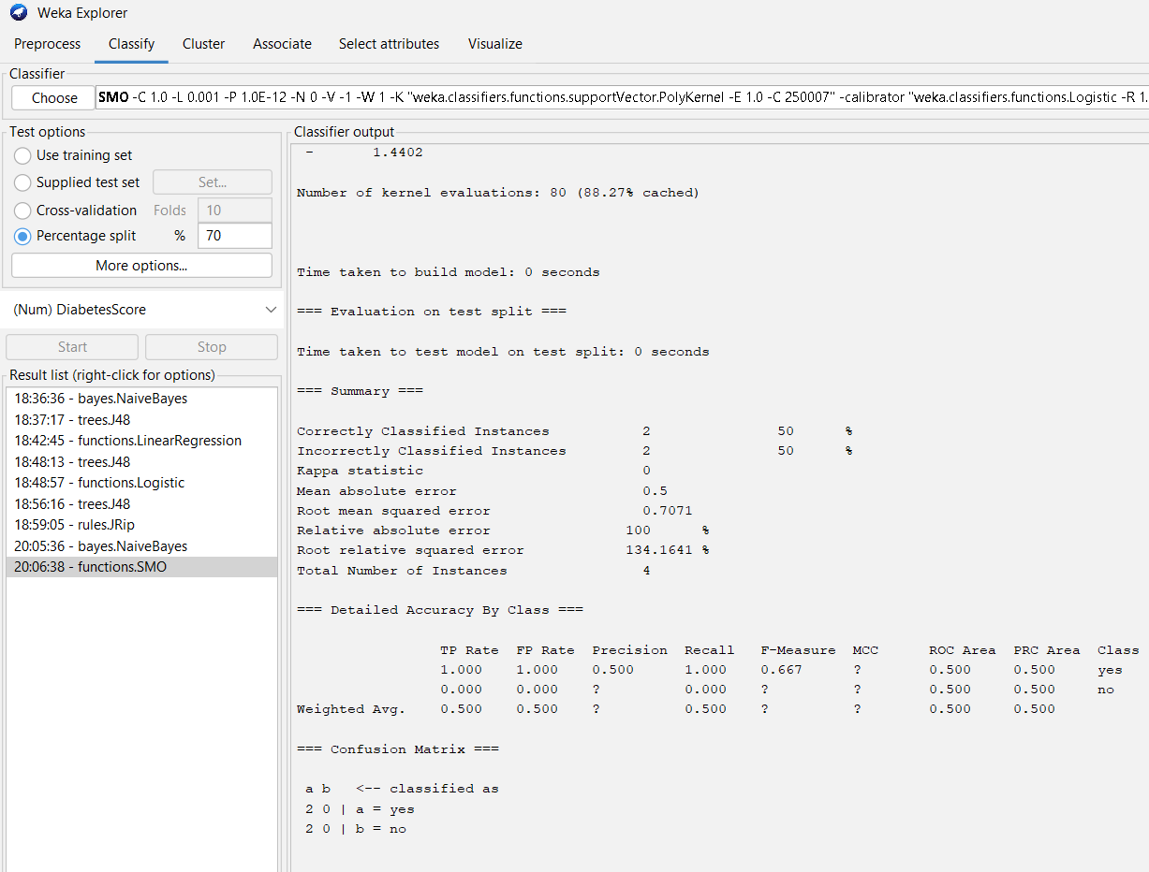Q8. R Binning + Histogram
Using the given student marks:

55, 60, 71, 63, 55, 65, 50, 55, 58, 59, 61, 63, 65, 67, 71, 72, 75

Partition them into three bins using:

(a) Equal-frequency / equal-depth
(b) Equal-width
(c) Clustering

Then plot the data points using a histogram.

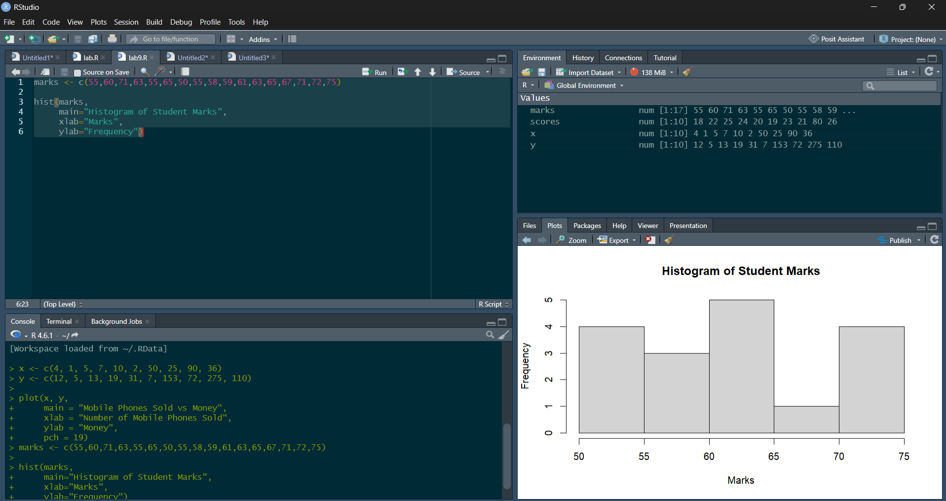

Q9. Decision Tree + Rule-Based Induction
Given the decision tree:

Height > 180 cm → Weight > 80 kg

Tasks:

(a) Create the dataset in ARFF format, calculate accuracy and make a decision.

(b) Generate rules using rule-based induction.

(c) Compare both algorithms and plot the confusion matrix.
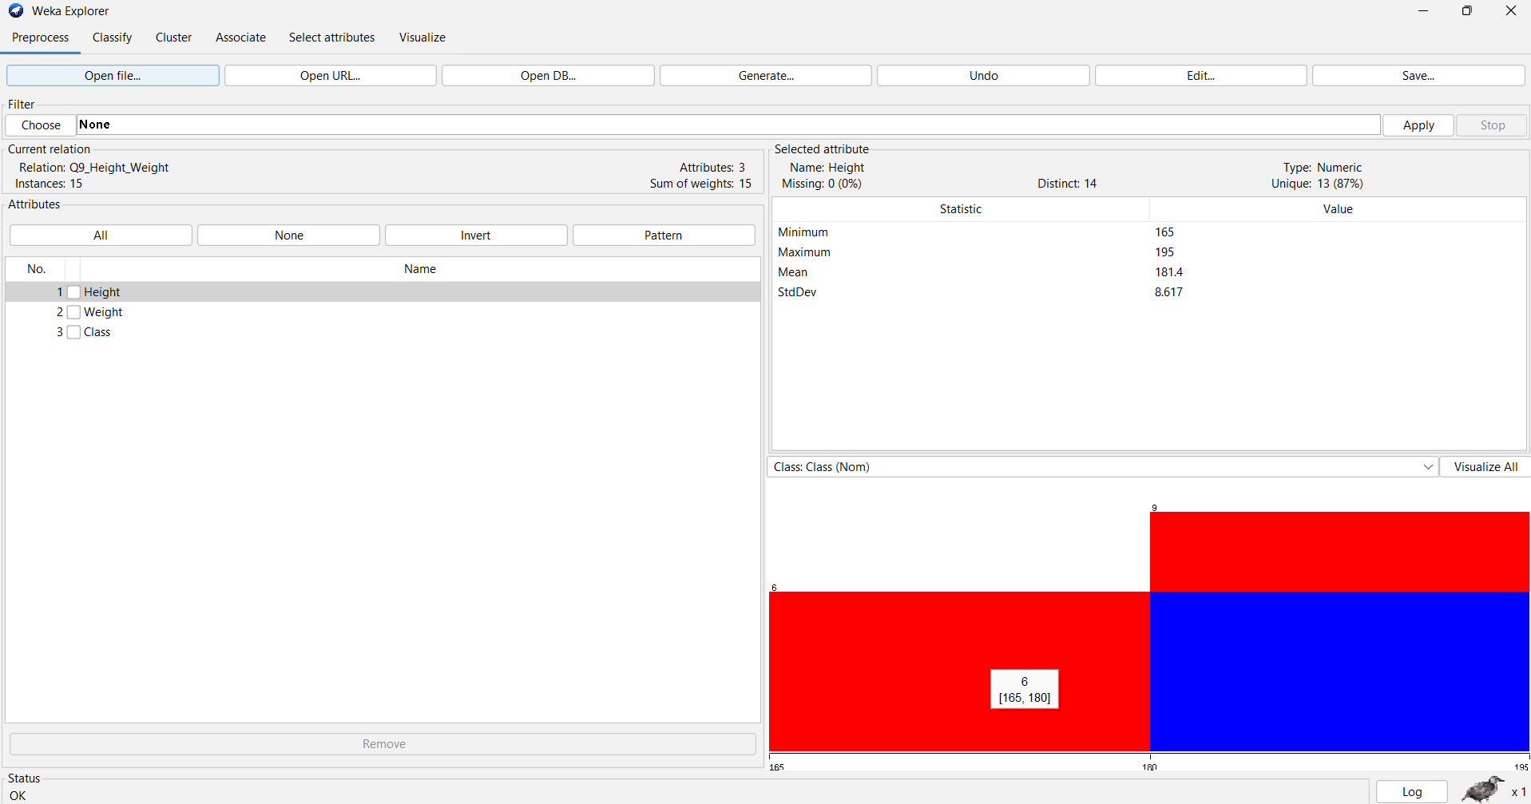

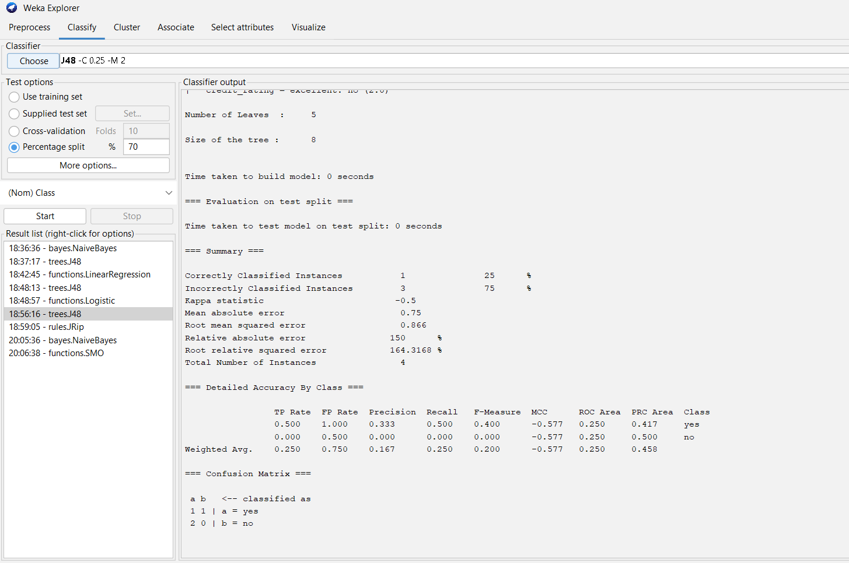

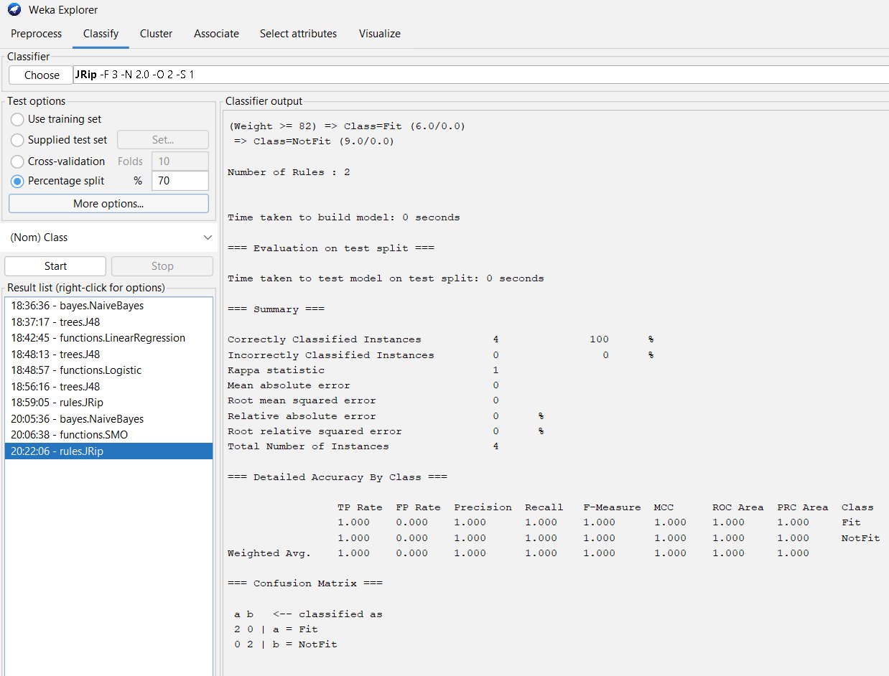
Q10. Apriori vs FP-Growth
Create an ARFF file for the given Sony/BPL/LG/Samsung/Onida dataset.
Implement:
Apriori
FP-Growth
Compare the rules generated by both algorithms and identify the unique rules.
Given:
Minimum support = 2
Confidence = 50%

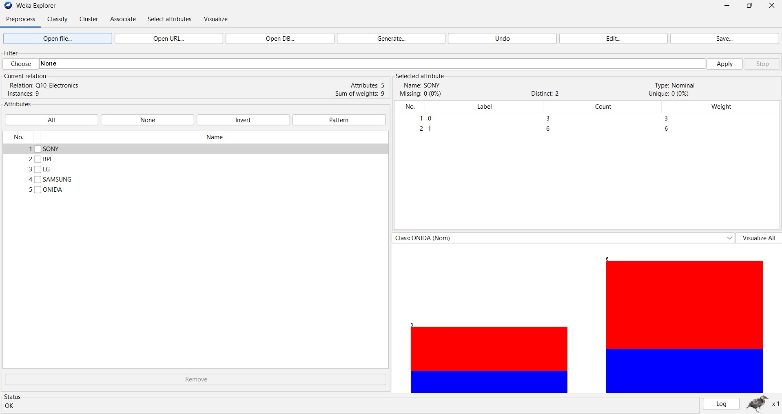

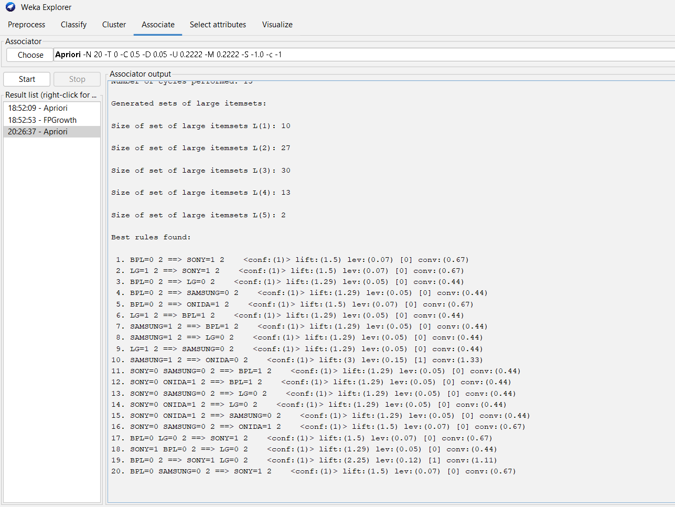

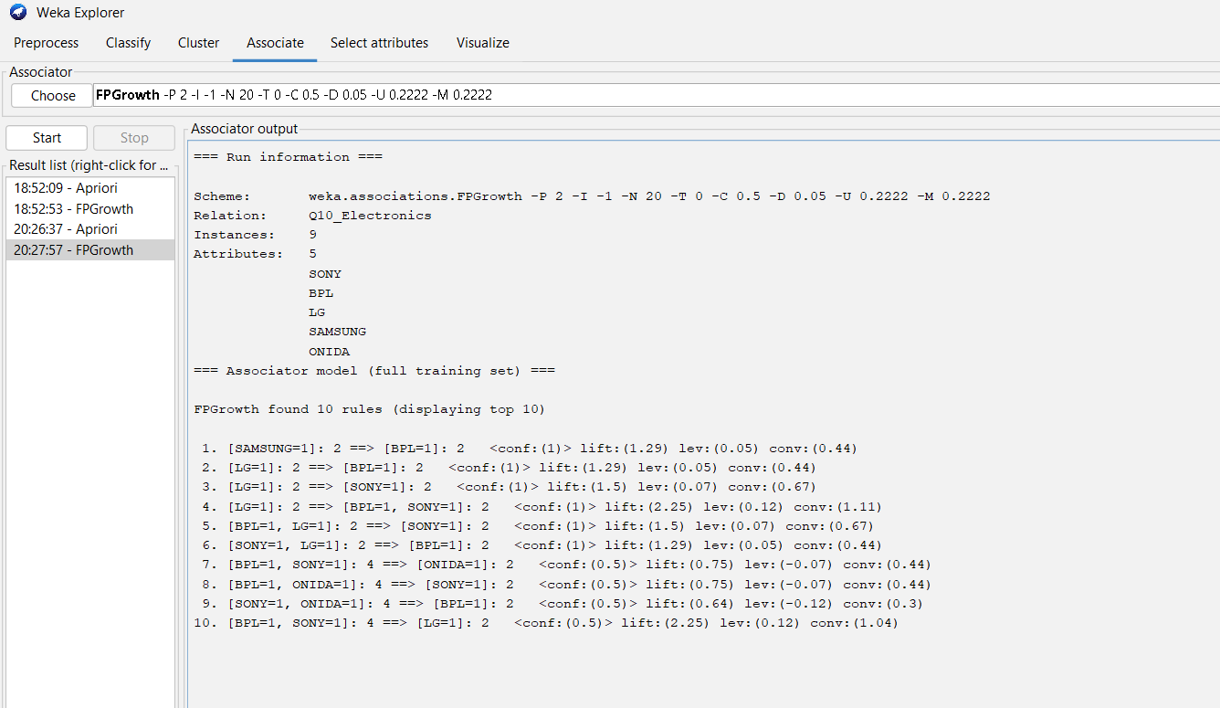

Q11. Normalization
Given the batsman's strike rates:
100, 70, 60, 90, 90
Perform:
(a) Min-Max normalization with min = 0 and max = 1
(b) Z-score normalization
(c) Z-score normalization using mean absolute deviation instead of standard deviation
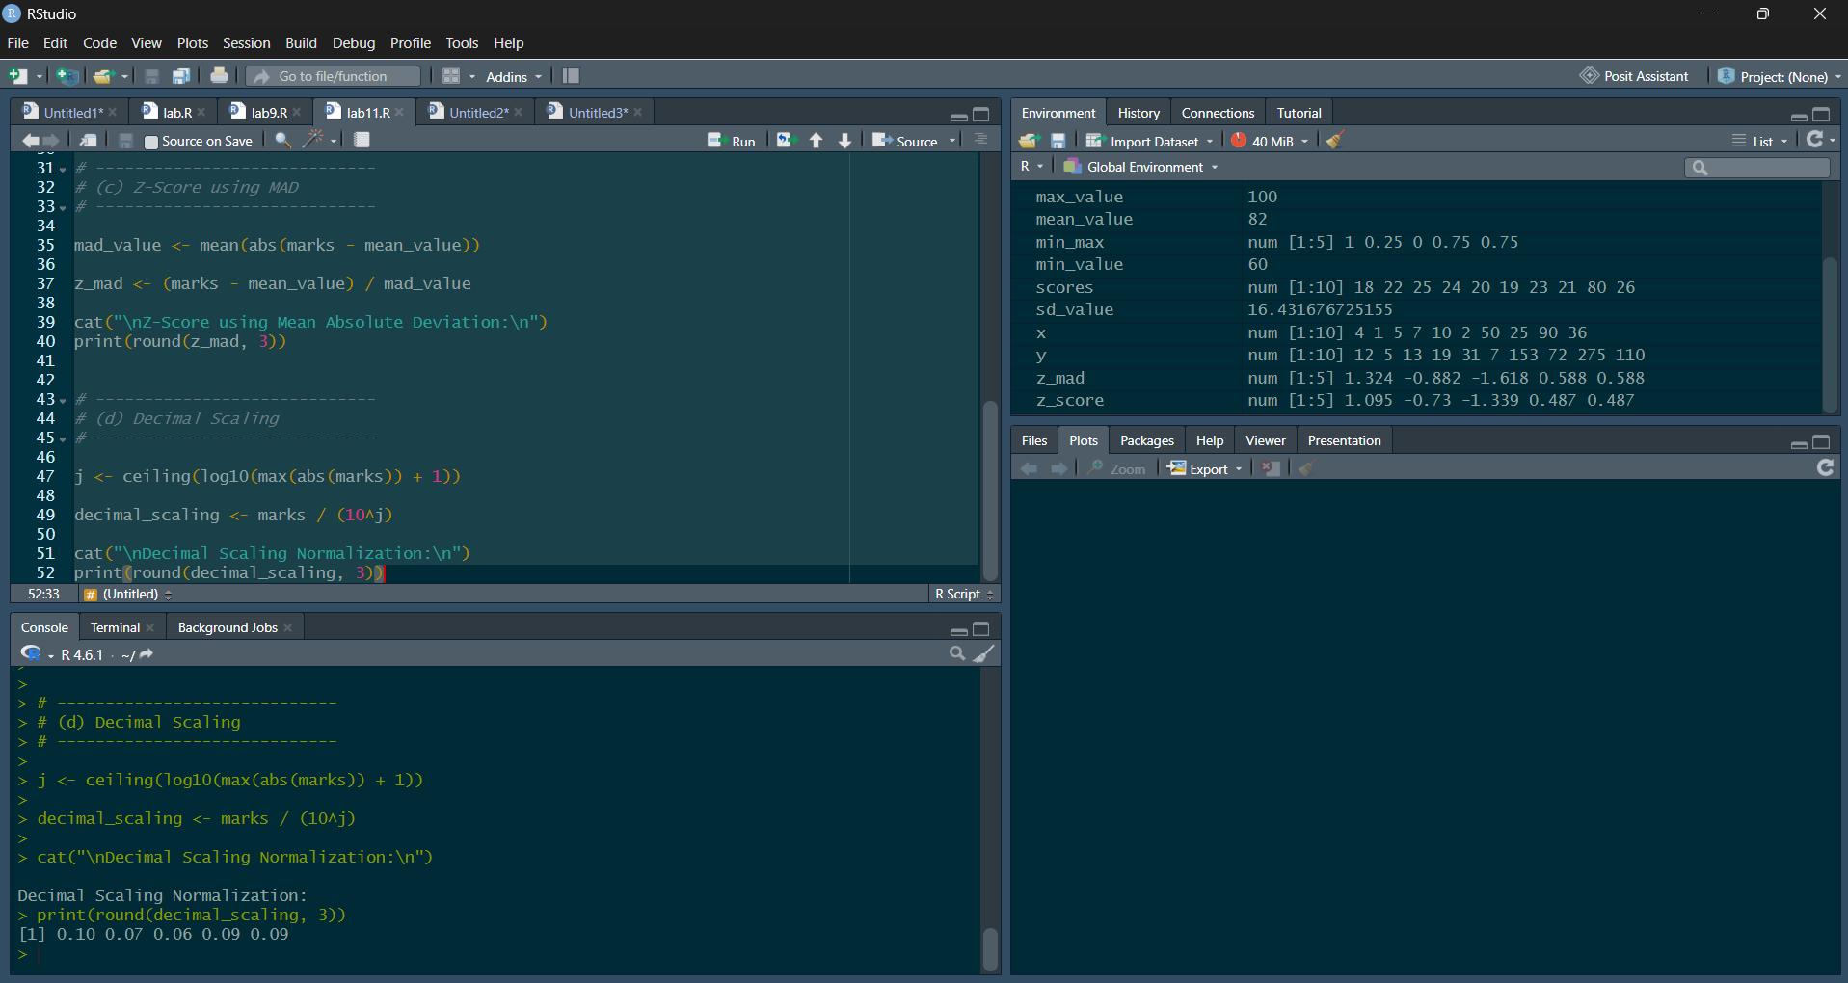
(d) Decimal scaling normalization.

Q12. Standard Deviation and Variance
For the given AvgSpeed and TotalTime values of 9 cars:
(a) Calculate the standard deviation of AvgSpeed and TotalTime.
(b) Calculate the variance of AvgSpeed and TotalTime.

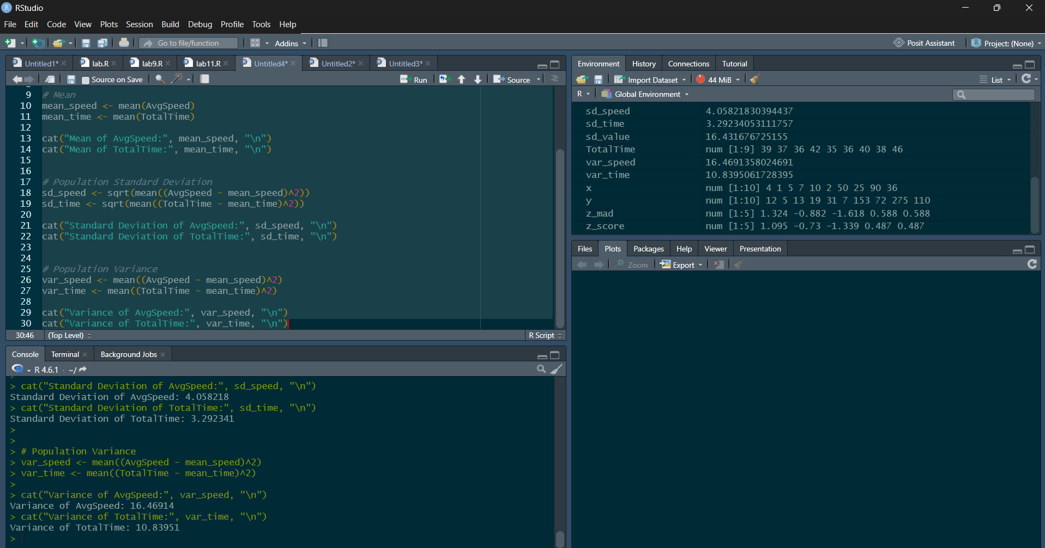

Q13. Apriori + FP-Growth + Strong Rules
Using the given 5 transactions:
Find all frequent itemsets using Apriori and FP-Growth
Compare the efficiency of the two mining processes
List all strong association rules matching the given metarule

